Date:
TASK 3: Bell States and Entanglement Entropy

Aim: To construct Bell States via Tensor Products and Measuring Entanglement Entropy in Bipartite.
- Construct all four Bell states (|Φ⁺⟩, |Φ⁻⟩, |Ψ⁺⟩, |Ψ⁻⟩) using quantum gates (Hadamard and CNOT).
- Measure their entanglement entropy to verify that they are maximally entangled (entropy
= 1).
- Compare with a product state (|00⟩) to confirm it has zero entanglement (entropy = 0).

- Mathematical Model
  - Quantum Gates Representation
    - Hadamard Gate (H)
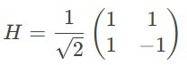
- Transforms basis states:
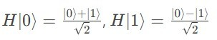

Identity Gate (I)
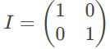
- Leaves qubit states unchanged.

CNOT Gate
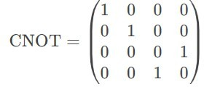
- Flips the target qubit if the control qubit is ∣1⟩.

Bell States Construction
Bell states are constructed by applying H to the first qubit followed by CNOT:
a. |Φ+⟩

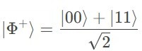
- Constructed from ∣00⟩.
b. |Φ–⟩
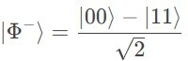
- Constructed from ∣10⟩.
c. |Ψ+⟩
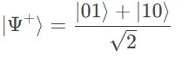
- Constructed from ∣01⟩.
d. |Ψ–⟩
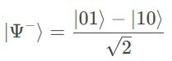
- Constructed from ∣11⟩.

Partial Trace Operation
Given a density matrix ρ for a bipartite system A⊗B, the partial trace over subsystem B is
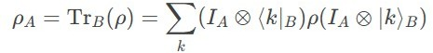
where {∣k⟩B} is a basis for B.

Entanglement Entropy (Von Neumann Entropy)
For a pure bipartite state ∣ψ⟩AB, the entanglement entropy is the von Neumann entropy of the reduced density matrix ρ_{A}=Tr_{B}(∣ψ⟩⟨ψ∣).
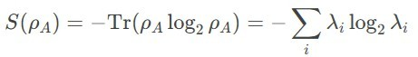
where λi are the eigenvalues of ρA.

Algorithm
- Define quantum gates
- Create entangled Bell states using tensor products.
- Reshape the states for partial trace computation.
- Calculate entanglement entropy of bipartite state
- Compute eigenvalues (using eigh for Hermitian matrices)
- Compute von Neumann entropy.

Program
import numpy as np
from math import log2, sqrt

print("\n" + "="*50)
print("TASK 3: BELL STATES AND ENTANGLEMENT ENTROPY")
print("="*50)

# Define quantum gates
H = 1/sqrt(2) * np.array([[1, 1], [1, -1]]) # Hadamard gate I = np.eye(2) # Identity gate
CNOT = np.array([[1,0,0,0], [0,1,0,0], [0,0,0,1], [0,0,1,0]]) # CNOT gate

class BellStates: @staticmethod def phi_plus():
"""Construct |Φ⁺⟩ = (|00⟩ + |11⟩)/√2""" state = np.kron([1, 0], [1, 0]) # |00⟩
state = np.kron(H, I) @ state # Apply H to first qubit return CNOT @ state # Apply CNOT

@staticmethod def phi_minus():
"""Construct |Φ⁻⟩ = (|00⟩ - |11⟩)/√2""" state = np.kron([0, 1], [1, 0]) # |10⟩ state = np.kron(H, I) @ state
return CNOT @ state

@staticmethod def psi_plus():
"""Construct |Ψ⁺⟩ = (|01⟩ + |10⟩)/√2"""

state = np.kron([1, 0], [0, 1]) # |01⟩ state = np.kron(H, I) @ state
return CNOT @ state

@staticmethod def psi_minus():
"""Construct |Ψ⁻⟩ = (|01⟩ - |10⟩)/√2""" state = np.kron([0, 1], [0, 1]) # |11⟩ state = np.kron(H, I) @ state
return CNOT @ state

def partial_trace(rho, dims, axis=0): """
Compute partial trace of density matrix rho
dims: list of dimensions of each subsystem [dA, dB] axis: 0 for tracing out B, 1 for tracing out A
"""
dA, dB = dims
if axis == 0: # Trace out B
rho_reduced = np.zeros((dA, dA), dtype=complex) for i in range(dA):
for j in range(dA): for k in range(dB):
rho_reduced[i,j] += rho[i*dB + k, j*dB + k] else: # Trace out A
rho_reduced = np.zeros((dB, dB), dtype=complex) for i in range(dB):
for j in range(dB): for k in range(dA):
rho_reduced[i,j] += rho[k*dB + i, k*dB + j] return rho_reduced

def entanglement_entropy(state): """
Calculate entanglement entropy of bipartite state Input: state vector or density matrix
Output: entanglement entropy """
# Convert state to density matrix if it's a state vector if state.ndim == 1:
rho = np.outer(state, state.conj()) else:

rho = state

# Partial trace over subsystem B (assuming 2-qubit system) rho_A = partial_trace(rho, [2, 2], axis=1)

# Compute eigenvalues (using eigh for Hermitian matrices) eigvals = np.linalg.eigvalsh(rho_A)

# Calculate von Neumann entropy entropy = 0.0
for lamda in eigvals:
if lamda > 1e-10: # avoid log(0) entropy -= lamda * log2(lamda)

return entropy

# Example usage
if name == " main ": # Construct Bell states
phi_p = BellStates.phi_plus() phi_m = BellStates.phi_minus() psi_p = BellStates.psi_plus() psi_m = BellStates.psi_minus()

print(f"Bell state |Φ⁺⟩ =", phi_p) print(f"Bell state |Φ⁻⟩ =", phi_m) print(f"Bell state |Ψ⁺⟩ =", psi_p) print(f"Bell state |Ψ⁻⟩ =", psi_m)

# Verify entanglement entropy (should be 1 for maximally entangled states)
print(f"Entanglement entropy of |Φ⁺⟩: {entanglement_entropy(phi_p):.4f}") print(f"Entanglement entropy of |Φ⁻⟩: {entanglement_entropy(phi_m):.4f}") print(f"Entanglement entropy of |Ψ⁺⟩: {entanglement_entropy(psi_p):.4f}") print(f"Entanglement entropy of |Ψ⁻⟩: {entanglement_entropy(psi_m):.4f}")

# Verify product state has zero entanglement entropy product_state = np.kron([1, 0], [1, 0]) # |00⟩
print(f"Entanglement entropy of |00⟩: {entanglement_entropy(product_state):.4f}")

Result
Bell states were constructed and their entanglement entropy was accurately calculated.

